

**Textiles Collection**

***to support projects across County, including International***

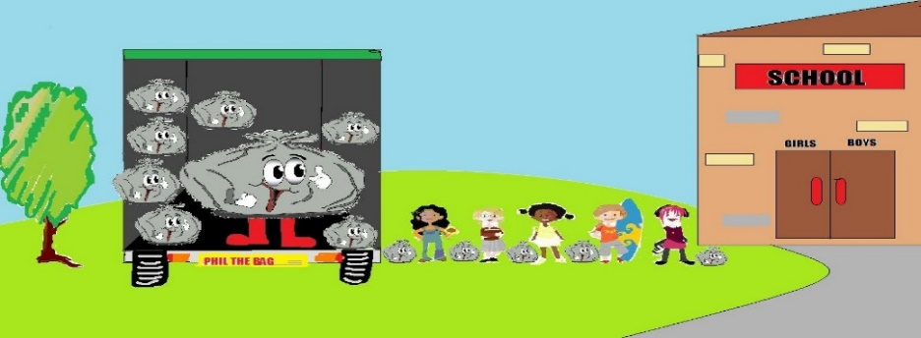It is very simple and raises substantial amounts

**WANTED!**

All types of clothing, accessories and household fabrics, including shoes, bags, belts, hats, gloves, bed linen, towels, blankets and sleeping bags

***Any items that are originally sold as a pair such as footwear and gloves MUST be sent as a pair.***

***Please note we cannot accept***

* *Clothing with school logo or work logos.*
* *Footwear or accessories that show any heavy signs of damage or stains. (Certain tears, holes and/or rips ‘may’ be accepted if they are specifically part of the original manufacturing process/design).*
* *Cushion Covers & Curtains*

**HOW CAN YOU HELP?**

Please collect unwanted items in bin liner bags.

*(do not overfill as they have to fit in the chute at the textiles bin)*

**Textile Bins can be found at**

* Goodwin Way Car Park, Roffey, Horsham RH13 6SQ

(behind Millennium Hall)

* Horsham, Dukes Square Car Park, Denne Road, RH12 1GZ

*All textiles are recycled and re-used both locally and globally by those who need them most. This saves many tonnes of textiles from going to landfill.*

**Any questions please email: ccgirlguidingsussexcentral@gmail.com**